Install Minikube from <https://minikube.sigs.k8s.io/docs/start/>

Download .exe and install

To start,

Open command prompt and type “minikube start”

You will see below error:

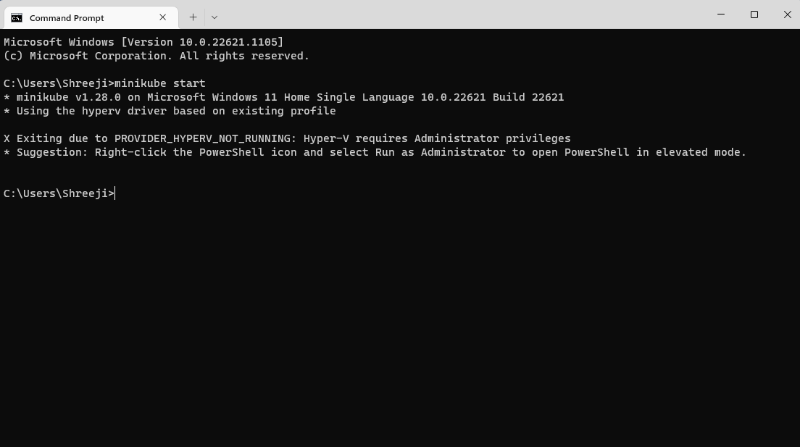

We need hypervisor, enable it from here

<https://learn.microsoft.com/en-us/virtualization/hyper-v-on-windows/quick-start/enable-hyper-v>

Open a PowerShell console as Administrator, and run the following command:

Enable-WindowsOptionalFeature -Online -FeatureName Microsoft-Hyper-V -All

If Hyper-V was not previously active, you will need to reboot.

Got below error; 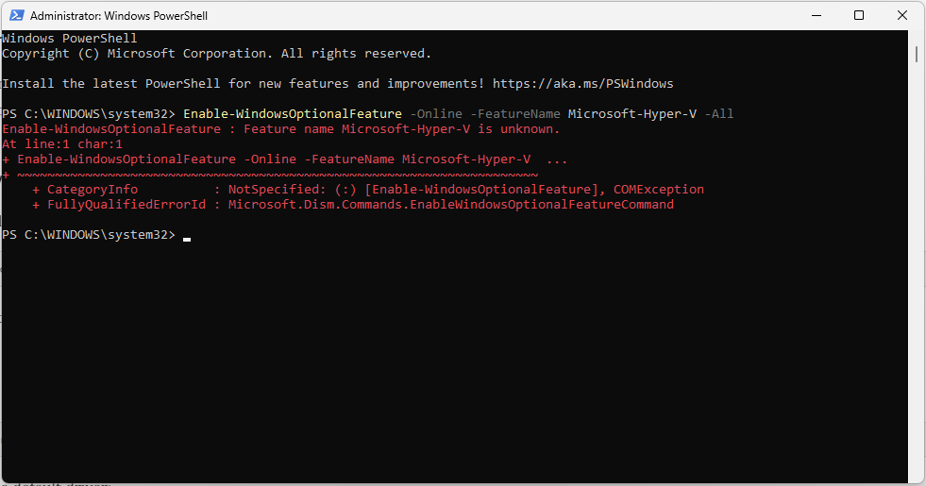

Trying to install Docker Desktop Now

Got Below Error

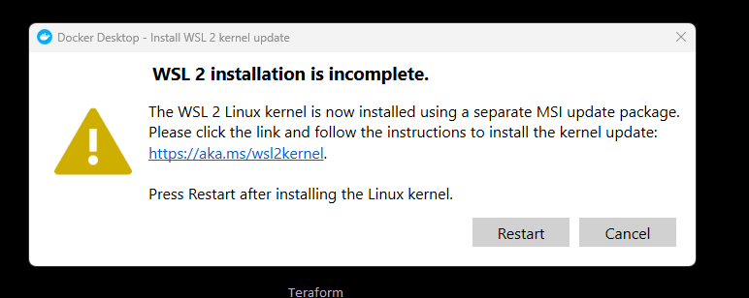

Installing WSL2 from <https://learn.microsoft.com/en-gb/windows/wsl/install-manual#step-4---download-the-linux-kernel-update-package>

Restarted : 